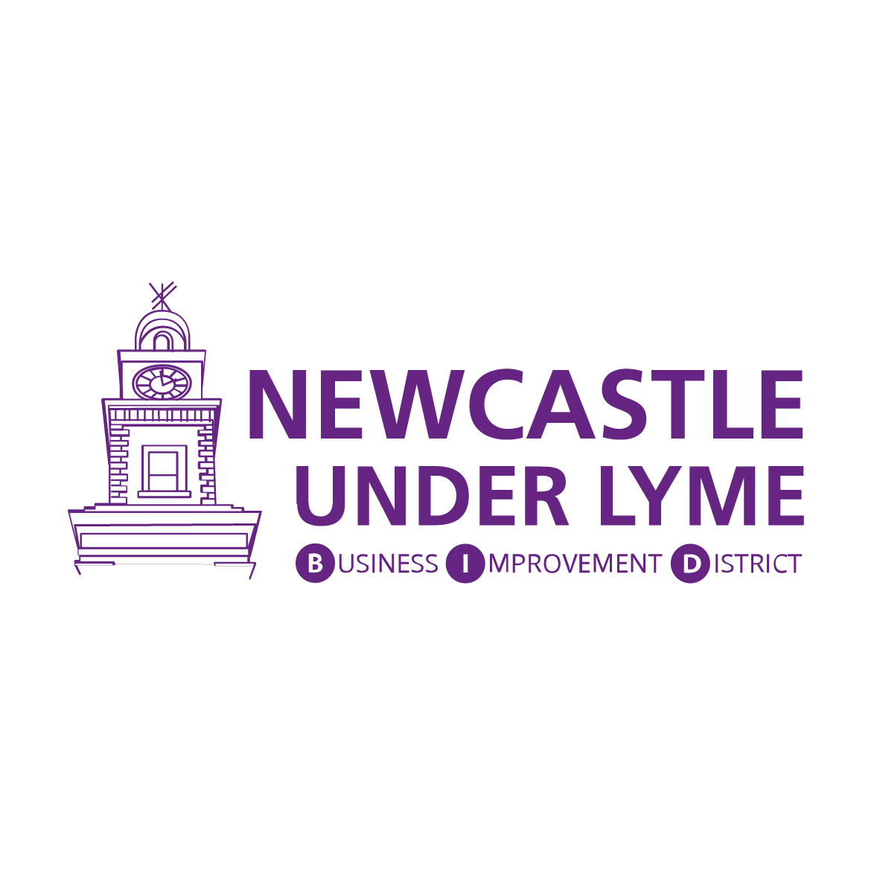

Newcastle-under-Lyme BID Shop Front Improvement Scheme
These guidance notes are provided to help you understand the aims of the Shop Front Improvement Scheme and how you can make an application for funding.
The Newcastle-under-Lyme BID Shop Front Improvement Scheme is an exciting initiative aimed at enhancing the appearance and vitality of our town's commercial areas. The scheme aims to support local businesses by offering financial assistance to undertake shop front renovations, ensuring a more appealing and vibrant shopping experience for residents and visitors alike.
Businesses can receive up to £250 match funding of improvements from the scheme which designed to improve shop fronts in selected areas as a means of supporting the growth of local businesses, improving the local environment, and raising the image of the town centre amongst locals and visitors as well as:
- Enhancing Aesthetics: The scheme aims to enhance the visual appeal of the town's commercial areas by encouraging businesses to improve their shop fronts, creating an attractive and inviting environment.
- Preserving Heritage: We recognise the historical significance of Newcastle-under-Lyme, the scheme encourages the preservation and restoration of heritage elements in shop fronts, maintaining the town's unique character.
- Boosting Economic Growth: By enhancing the overall appearance of the town's commercial areas, we aim to attract more customers, encourage footfall, and support the local economy.

Benefits of Participating:
- Financial Support: The Shop Front Improvement Scheme provides financial grants to eligible businesses, helping to cover the costs of shop front renovations, including signage, painting, repairs, and restoration of heritage features.
- Increased Visibility: A renovated shop front will make your business more visually appealing and help it stand out among competitors, attracting more customers and increasing brand visibility.
- Community Pride: By participating in the scheme, you contribute to the overall improvement of Newcastle-under-Lyme, fostering a sense of community pride and demonstrating your commitment to the town.

What funding is available?
The scheme will provide matching funding of 50% up to £250 towards expenditure on works.
Funding is discretionary and subject to availability. The inclusion of a building within the eligible area does not give any automatic entitlement to a grant.
The scheme will not support works which have already been undertaken or any works which are started prior to a formal offer of grant funding being made.
The grant can only be used for business units located within Zone 1 and 2 of the Newcastle-under-Lyme BID area.
In the event of the scheme being oversubscribed, priority will be given to improvements that would be seen to have the most impact and to businesses that have not yet received any financial support from Newcastle-under-Lyme BID.

Who can apply for the fund?
All BID levy-paying businesses and voluntary levy-payers who are looking to fix, upgrade and improve their shop frontage and are located within Zone 1 and Zone 2 of the BID area are eligible to apply for the fund.
A business will only be eligible if their levy payments are up to date.
If you’re not a levy-paying business (businesses with a rateable value below £12,001) but located within the BID area, you are eligible to apply to be a voluntary levy payer, and the scheme will, then be open for you to apply (contact us hello@nulbid.co.uk for more information).
Examples of eligible commercial premises include:
Shops: Retail, hairdressers, beauty salons, laundrettes, dry cleaners
Hospitality: Restaurants, public houses, cafes, and food takeaways
Financial and professional services: Estate Agents, accountants, banks
If you are unsure whether your business will qualify for a grant, please contact hello@nulbid.co.uk

What kinds of improvements will the scheme fund?
- Repainting of shop fronts.
- Repair of shop fronts.
- Repairs to or new shop front signage.

How do I apply?
To submit an application for funding, you will need:
- Completed an application form
- Schedule of works – giving full details of the improvement works that you intend to carry out.
- Proof of ownership/lease - If you do not own the property, you will need to provide proof that you have permission from the owner to carry out the works. The building owner must countersign your application to show that they have given permission for the works to be carried out.
- Copies of any statutory consent notifications (e.g., planning permission)

Applications for funding must be made by 30th September 2023, with improvements being completed within six months of approval.
Applications will be considered by a panel of the Newcastle-under-Lyme BID Board of Directors. All grant offers will be made in writing.
The Grant will be paid directly to the business on submission of receipted invoices and upon completion of the outlined work.
Claims of eligible expenditure incurred must be supported by a fully transparent audit trail traceable through invoices and bank statements.

